# Task 1

this is a  **paragraph**  testing

2nd paragraph testing

# Code:

x = 0:pi/100:2*pi;  
y = sin(x);  
plot(x,y)

# Output:

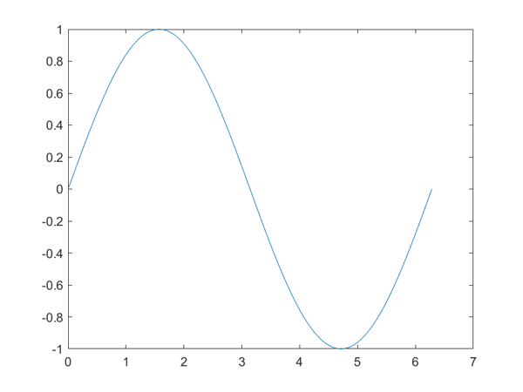

# Task 2

# Simulink Model:

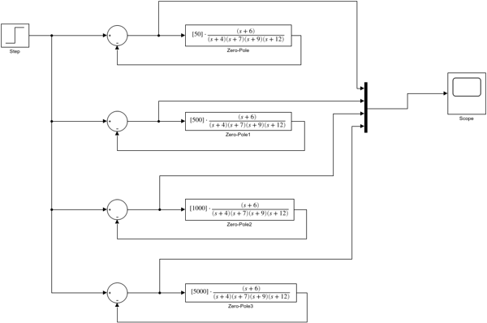

# Simulink Output:

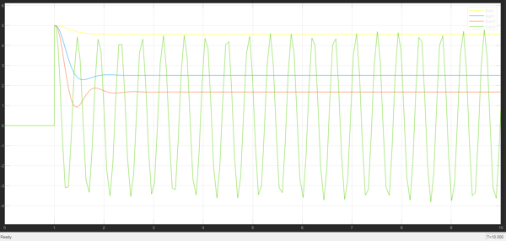

# Task 3

# Simulink Model:

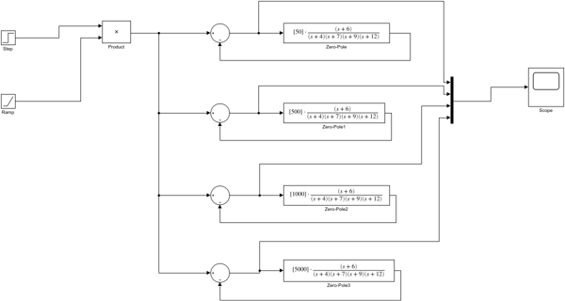

# Simulink Output:

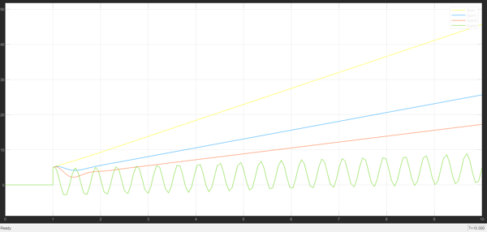

# Task 4

# Simulink Model:

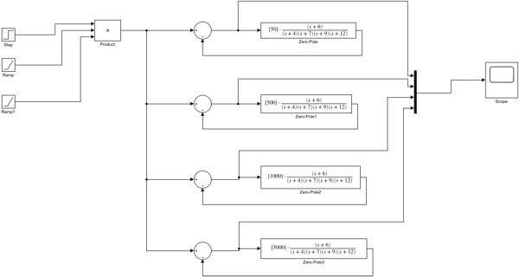

# Simulink Output:

